4.6 Triple Integrals in Cylindrical & Spherical Coordinates Worksheet

- Let the point be given in rectangular coordinates. Express this point in terms of both cylindrical and spherical coordinates.

Cylindrical Coordinates:

We first think about where this point has been plotted and will attempt to determine the value of r and . We see that in the xy plane we are working with the following triangle.
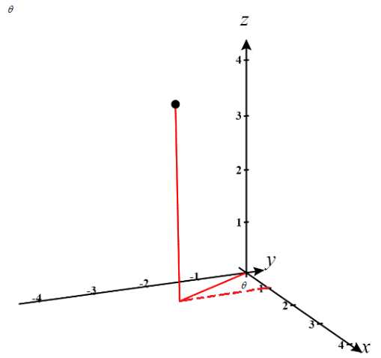
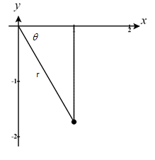

Therefore, we can see that and .
So, we have that the cylindrical coordinates are .

Spherical Coordinates:

We first think about where this point has been plotted and will attempt to determine the value of .
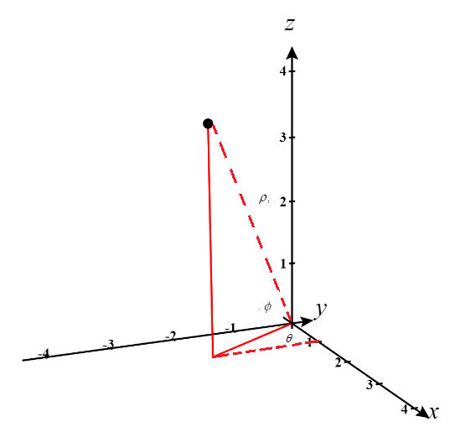

We already established above that .
We know that .
We also know that

So, we have that the spherical coordinates are .

- Set up, but do not evaluate, the integral , where E is bounded by the xy-plane and the hemispheres and .

We can see that the region of integration is the volume that exists beneath the xy-plane and is inside a sphere of radius 3 but outside a sphere of radius 2. A picture of this region is shown below.
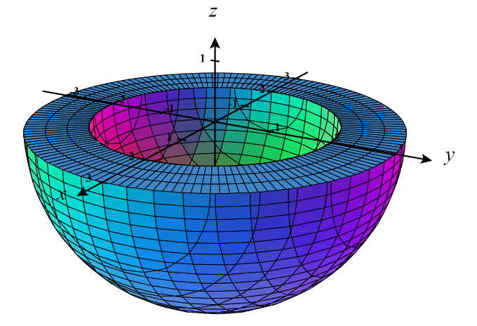

We can define this region as:

Therefore, we can setup our integral as:

- Set up, but do not evaluate, a triple integration to find the volume of a solid E, where E is enclosed by and .
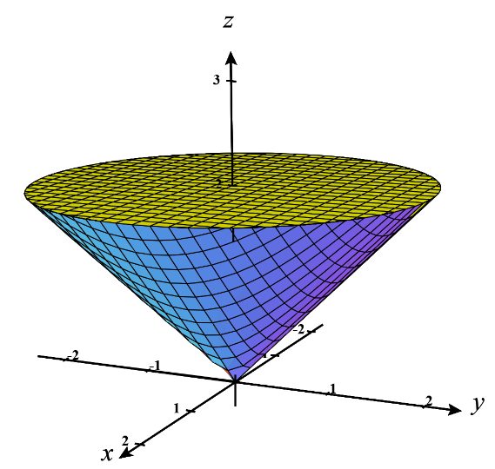
We first create a picture of the region in question.

We can immediately see that which implies that .
We see that the plane intersects the cone at which is a circle of radius 2. If we project the solid to the xy-plane produces the region D defined by .

Therefore, we calculate.

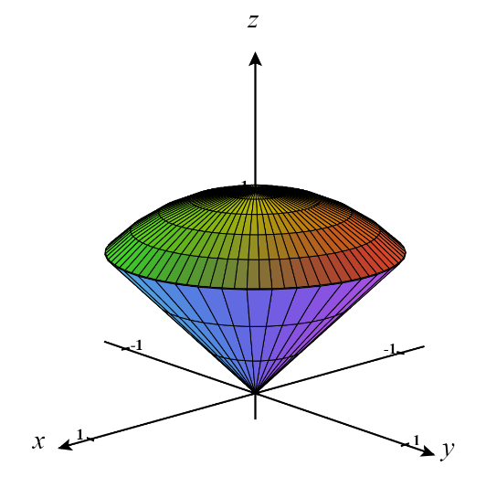
- Consider the solid bounded by the cone and the sphere .
- Use spherical coordinates to find the volume of this solid.

We first create a picture of the region in question.

We can see that the cone and the sphere intersect when
(that is at a circle of radius ).

We can then see that we have a triangle formed like the one shown below.
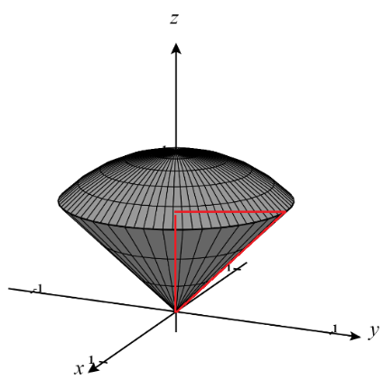

We know the length of the top side of this triangle by the radius of the circle of intersection from the sphere and the cone and we know the hypotenuse of this triangle is 1 since this represents the radius of the sphere.

Therefore we can conclude that the missing side has length and that .
So, we describe the region of integration as and thus the volume of the given region given by the following iterated integral.

- Use cylindrical coordinates to find the volume of this solid.

We reference again the picture we created of this solid in part (a).
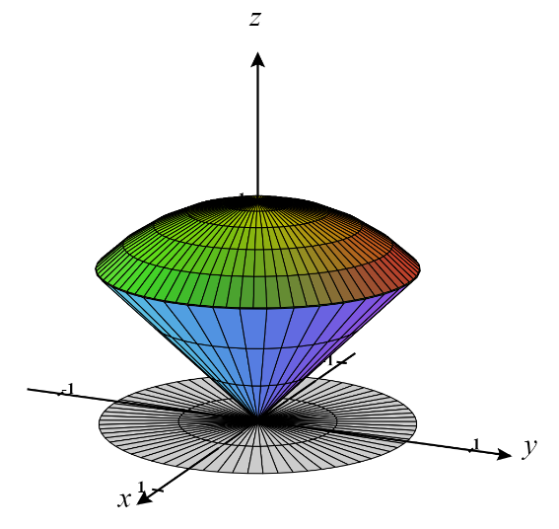
We can immediately see that which implies that . We still know the intersection of the sphere and the cone occurs at a circle . So we can then say that the projection of the solid to the xy-plane produces the region D defined by .

Therefore, we express the volume of the solid as

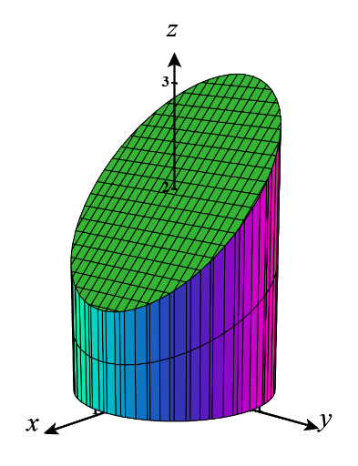
- Consider the region E bounded by the xy-plane, the cylinder and the plane . Calculate the value of
We first create a picture of the region in question.

We can immediately see that which implies that .
If we project the solid to the xy-plane produces the region D defined by .

Therefore, we calculate.

